SIES COLLEGE OF ARTS, SCIENCE AND COMMERCE, SION(W)

DEPARTMENT OF ENGLISH

TITLE: ALUMNI INTERACTION ON CAREERS IN TEACHING

DATE & TIME OF THE EVENT: 26th August 2023, 10:30 am to 11:30 am

NO. OF PARTICIPANTS: 21

LOCATION: ROOM NO. 30

AIM AND OBJECTIVES: To gain insights on the B.Ed Course and the prospects in teaching at schools and junior colleges.

NAME OF RESOURCE PERSON: Ms. Marina Kumar and Ms. Sneha Jacob

REPORT: The Department of English had organized an alumni meet on 26th August 2023 in order to provide the students some insights about the B.Ed course. The speakers of the event were Ms. Marina Kumar and Ms. Sneha Jacob. Both the speakers helped the students to broaden their knowledge about the course and its prospects. All the students who attended the event could clear their doubts from the speakers as they were currently pursuing this course. The speaker Ms. Sneha Jacob is also an English teacher while she is pursuing B.Ed. Her experiences and ideologies could act as valuable information and advice for all the students. They also talked about entrance examination and its process. The variations in course and structure were also well explained by them. They also talked about the colleges to apply to and the institutions that provide hybrid teaching as well. All the students could have a clear picture of the course and its benefits. The students who aspire to have a career in teaching could gain the information in a detailed manner. This paved a road for them with more clarity and better ideologies.

OUTCOME: Everyone could understand the structure and scope of the B.Ed. course.

Annexure 2: Attendance record:

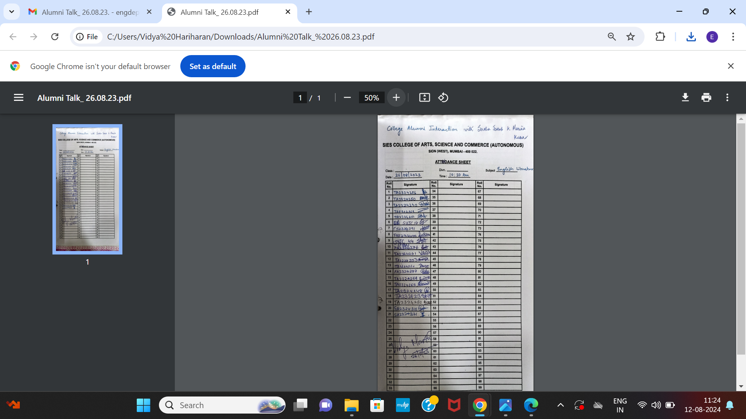

Attendance 3: Photos

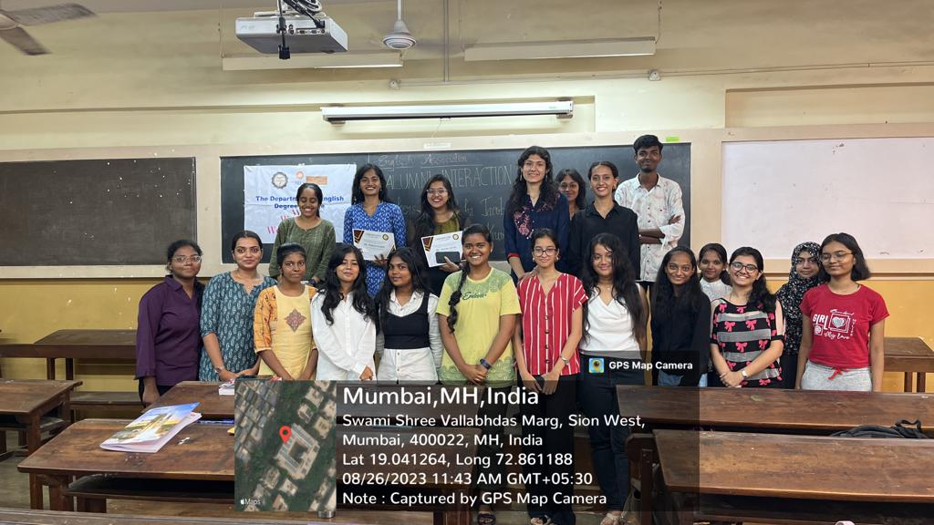

Participants.

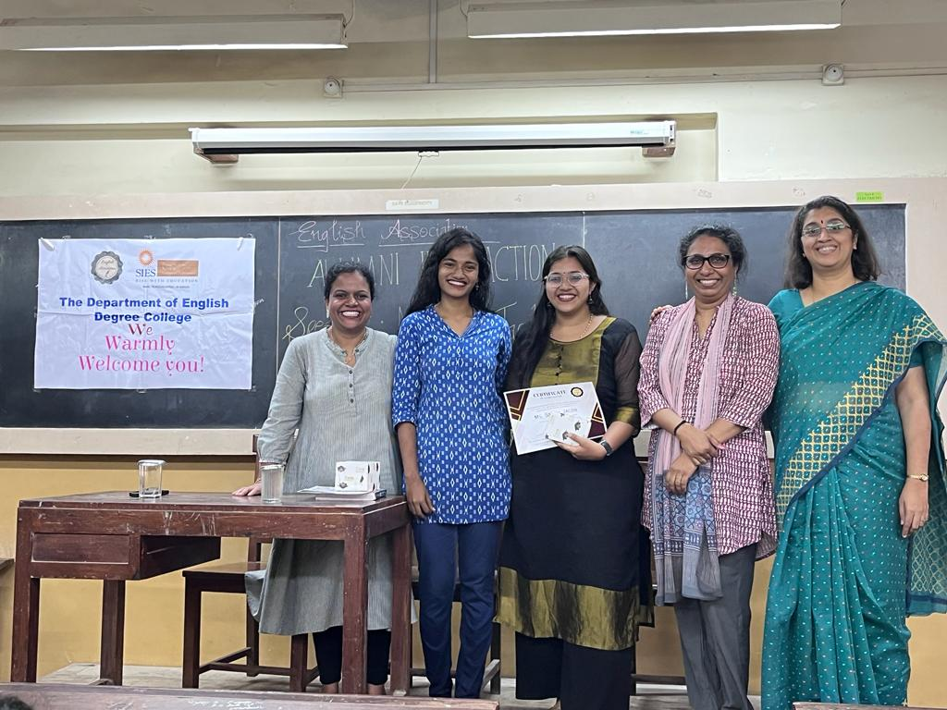

The department of English staff with Ms Marina Kumar and Ms. Sneha Jacob.

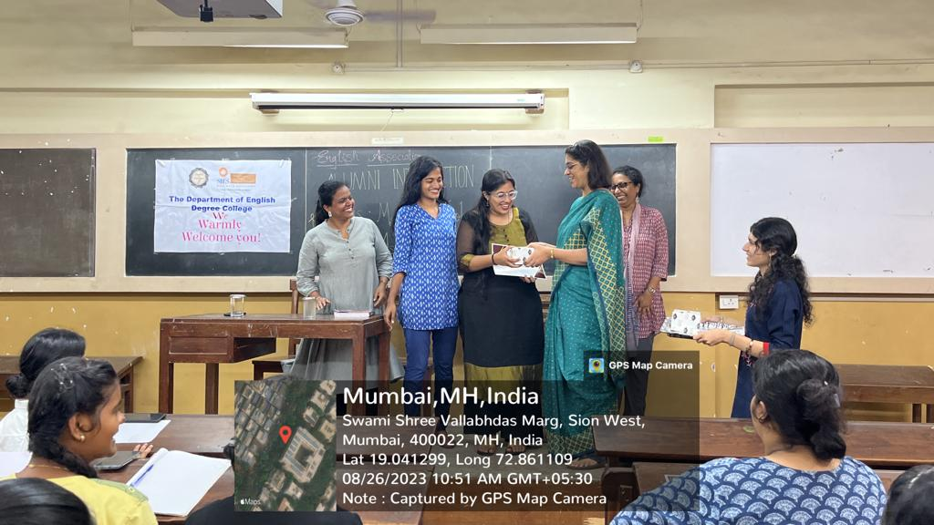

Felicitation of the Resource Persons

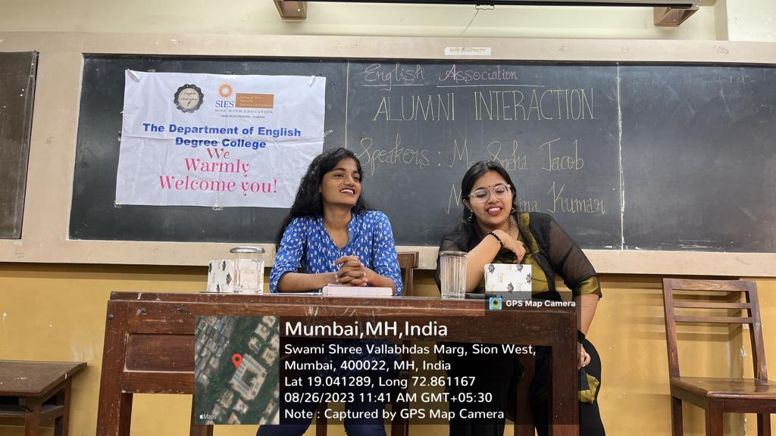

The talk in progress.

Report prepared by:

Vidya Hariharan

Sign of HOD:

Prof. Dr. Lakshmi Muthukumar

Stamp and signature of Principal:

College Seal: